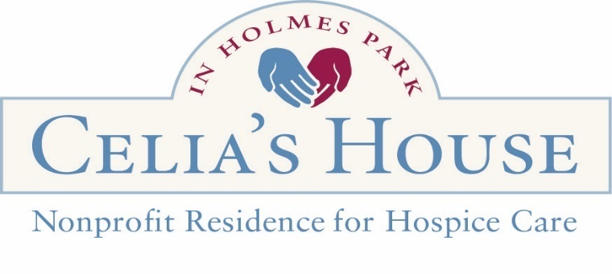

Dear Prospective Volunteer,

Thank you for your interest in volunteering at Celia’s House. The work we do here is made possible by compassionate people like you, and we are grateful that you are considering joining our community. Whether you’re drawn to hands-on resident care, behind-the-scenes support, or sharing a special gift or skill, there is a meaningful place for you here.

Who We Are
Southern Oregon Friends of Hospice is a 501(c)(3) non-profit organization that operates Celia’s House, a 12-bed hospice residence in Medford, Oregon. We offer a warm, home-like environment for people in the final chapter of their lives. Our care is provided in partnership with local hospice agencies, and our daily operations are sustained in large part by the dedication of more than 100 volunteers.
Our compassionate approach to end-of-life care is focused on comfort, dignity, and quality of life. We honor each resident’s wish to live their remaining days with peace and purpose by adhering to our core values of Being Present, Being Real, and Being Kind.

Volunteer Opportunities
We offer a variety of volunteer roles to match different interests, schedules, and strengths. If you have an area of interest that isn’t listed below, please note it on your application.
- Resident Support Volunteer (RSV): RSVs are trained to support our Care Staff by providing compassionate companionship and emotional support to residents and their loved ones at the bedside and duties carried out throughout the house. Shifts are 3 or 4 hours long, and RSV volunteers typically fill one shift per week.

- Front Desk: Front Desk volunteers serve in two-hour shifts and greet visitors with a warm and welcoming presence, help with check-in, and support the flow of daily activity at the house.

- Garden Team: If you love to be outside and don’t mind getting your hands dirty, our Garden Volunteers help tend and maintain our beautiful outdoor spaces on Wednesdays from 9am-12noon. No prior gardening experience is needed.

- Events: Assist with special events throughout the year in support of our mission.

- Fundraising: Support our development efforts by assisting with campaigns, donor outreach, and administrative tasks that help sustain our work.

- Music: Share the gift of music, bringing comfort, joy, and connection with our residents and their loved ones.

- Massage & Reiki: Licensed & certified practitioners provide therapeutic touch & energy-based support to residents, offering relief and relaxation.

- Pet Therapy: Bring your fully vaccinated and supportive pet to visit with residents who feel comforted by our furry friends.
Please complete the attached application and return it to the House in person, by email or mail. We look forward to welcoming you to our volunteer family.

Sincerely,



Becky Brown
Volunteer Coordinator
becky.brown@sofriendsofhospice.org
541-500-8911 ext. 312

Celia’s House
217 S. Modoc Ave
Medford, OR 97504
sofriendsofhospice.org

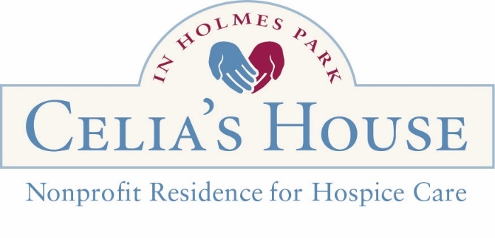
Volunteer Application

Today’s Date: __________________
clkm1111@gmail.com

Full Name: ____________________________________________________________

Birthdate (mm/dd/yyyy): ________________

Email: ________________________________________________________________

Address: _______________________________ City ________________ Zip _______

Phone: _______________________________ Cell: ___________________________

Emergency Contact Information

Name:_______________________________Relationship: _____________________

Phone Number: ______________________________________________________
Celia’s House Volunteer Opportunities

☐ Resident Support Volunteer
☐ Front Desk
☐ Garden Team
☐ Music ______________________

☐ Events____________________
☐ Fundraising ☐ Therapeutic Services____________

☐ Pet Therapy
☐ Other (please specify) ___________

Days/Hours Available:
Monday __________ Tuesday __________ Wednesday __________
Thursday _________ Friday _________ Saturday __________ Sunday _________

Please answer the following questions to the best of your ability.

Why do you want to be a volunteer at Celia’s House?

____________________________________________________________________________________________________________________________________________

What is your professional background, and are you interested in applying these specific skills and talents as a volunteer role? ☐ Yes ☐ No

(Associated skills and talents) _____________________________________________

_____________________________________________________________________

What other languages do you speak fluently? _________________________________________________

How did you learn about Celia’s House? _____________________________________
Allergies or medical conditions you would like us to be aware of:

____________________________________________________________________________

Do you have any health or physical limitations we need to consider in assigning you to volunteer tasks?

Do you have any previous experience or training in providing end-of-life care, grief support, or related areas? ☐ Yes☐ No
(If yes, please describe.) __________________________________________________

Have you ever volunteered in a hospice or similar setting before? ☐ Yes ☐ No
(If yes, please provide details.) ____________________________________________

Signature: _____________________________________ Date: _________________

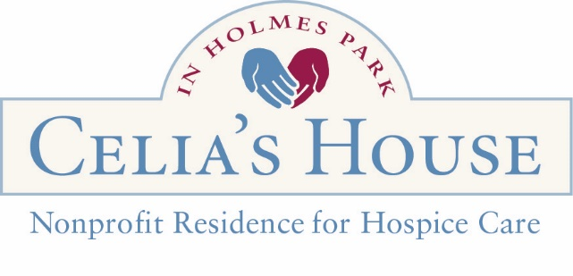
Background Check Form - REQUIRED
Please print legibly.

Full Legal Name: _______________________________________________________________________________

Previous Names/Aliases: ____________________________________________________________________

Date of Birth: ______________________________

Driver’s License or State ID Number: ___________________________________

State that issued ID: ___________________

Email Address: ________________________________________________________________
You will receive an email from BCU - ORCHARDS. Please reply promptly to ensure timely processing of your background check.

Current Address: __________________________________________________________________________________

Phone Number: ___________________________________________________

Social Security Number (Optional): __________________________

Other Addresses in the last five years. Please list specific addresses and of residence: ____________________________________________________________________________________________________________________________________________________________________________________________________________________________________________________________________________________________________________________________________________________________________________________________________________________________________

Gender:

□ Male □ Female
□ Non-Binary
□ Prefer not to say

FOR OFFICE USE
Picture ID checked by: _________________________
Date of Submitted Background Check: _____________
Date of Approved Background Check: _____________

Background Check Form - REQUIRED

Race:
□ American Indian or Alaska Native - a person having origins in any of the original peoples of North or South America (including Central America), and who supports tribal affiliation or community attachment.
□ Asian - a person originating in any of the original peoples of East Asia, Southeast Asia, or the Indian subcontinent, including Cambodia, China, India, Japan, Korea, Malaysia, Pakistan, the Philippine Islands, Thailand, or Vietnam.
□ Black or African American - origins in any of the Black racial groups of Africa.
□ Native Hawaiian or Other Pacific Islander - a person having origins in any of the original peoples of Hawaii, Guam, Samoa, or other Pacific islands.
□ White - a person who has origins in any of the original peoples of Europe, the Middle East, or North Africa.
□ Prefer not to say

Ethnicity:
□ Hispanic or Latino/a - a person of Cuban, Mexican, Puerto Rican, South or Central American, or other Spanish culture or origin, regardless of race.
□ Not Hispanic or Latino/a
□ Prefer not to say

The role you plan to fill at the Celias House: __________________________________________________

If you have potentially disqualifying convictions or conditions, the BCU (Background Check Unit) must consider several factors to determine the risk of vulnerable individuals and your fitness to hold the position. Please provide any information about the details of your potentially disqualifying history, yourself, your training, education, work history, treatment, and circumstances since your potentially disqualifying history that you want the BCU to weigh. Add additional pages as needed. ___________________________________________________________________________________________________________________________________________________________________________________________________________________________________________________________________________________________________________________________

Background Check Form - REQUIRED

I understand that Celia’s House in Holmes Park is licensed as a Residential Care Facility by the Department of Human Services for Oregon. As such, people who work or volunteer with our residents must complete a background check. By signing, you affirm the following statements to be true.

- You have never been convicted of any form of abuse.

- If you do any form of professional work in the facility, you have all the proper licenses, certifications, and approvals to perform such tasks, or you will obtain all proper licenses, certifications, and approvals before performing such tasks. (i.e., food handlers license).

- You understand that completing this form will begin a background check process; failure to complete the background check process or pass the background check may limit your ability to work at Celia’s House in Holmes Park.

Signature: ________________________________________________ Date: ______________

REFERENCES - REQUIRED

Please list at least two people who know you well, one professionally and the other personally.
Name/Title: Relationship: phone or email address:

- _______________________________________________________________________________

- ______________________________________________________________________________

- ______________________________________________________________________________

- _______________________________________________________________________________
I understand that Celia’s House of Southern Oregon Friends of Hospice is a non-profit 501(c) 3. I allow Southern Oregon Friends of Hospice to contact my references and conduct a background check.

Signature: ______________________________________________ Date: _______________________

Issued: March 18, 2015
Reviewed: May 12, 2022, Reviewed by: Executive Director
Revised: Review Responsibility: Executive Director

1-3 Confidentiality

This is a confidentiality policy for Employees, Volunteers and Board Members. Respecting the privacy of our clients, donors, members, staff and volunteers and of Southern Oregon Friends of Hospice itself is a basic value of Southern Oregon Friends of Hospice.

Personal and financial information is confidential and should not be disclosed or discussed with anyone without permission or authorization from the executive director. Care shall also be taken to ensure that unauthorized individuals do not overhear any discussion of confidential information, and that documents containing confidential information are not left in the open or inadvertently shared. Employees, volunteers and board members of Southern Oregon Friends of Hospice may be exposed to information which is confidential and/or privileged and proprietary in nature. It is the policy of Southern Oregon Friends of Hospice that such information must be kept confidential both during and after employment or volunteer service.

Staff and volunteers, including board members, are expected to return materials containing privileged or confidential information at the time of separation from employment or expiration of service. Unauthorized disclosure of confidential or privileged information is a serious violation of this policy and will subject the person(s) who made the unauthorized disclosure to appropriate discipline, including removal/dismissal.

Certification
I have read Southern Oregon Friends of Hospice’s policy on confidentiality presented above. I agree to abide by the requirements of the policy and inform my supervisor immediately if I believe any violation (unintentional or otherwise) of the policy has occurred. I understand that violation of this policy will lead to disciplinary action, up to and including termination of my service with Southern Oregon Friends of Hospice.

Signature ________________________ Name ______________________ Date __________

